|  |  |  |  |
| --- | --- | --- | --- |
| **Learning Outcomes:** | **Assessment** | | |
| 1. Analyse and illustrate Big Data challenges to the business world; 2. Explain the impact of Big Data's five V's (volume, velocity, varie­ty veracity and value) using real world examples; 3. Apply architectural components and programming models of commonly used Big Data; 4. Install and execute a technological solution using open-source software framework. | Laboratory Work | Labs (Sessions 1-9) 30% | 6% Tableau Lab, Other Labs 3% each |
| Assignment | Group Assignment (Session 10) 30% | 15% Individual live demonstration & 15% Group presentation |
| Test | Test 1 (Session 7) & Test 2 (Session 11) 40% | 20% Test 1 on Sessions 1-4  20% Test 2 on Sessions 6-9 |

|  |  |  |  |  |  |  |  |  |  |  |  |
| --- | --- | --- | --- | --- | --- | --- | --- | --- | --- | --- | --- |
| TOPICS  (Textbook) | Session 1:  Understanding Big Data | Session 2:  Business Motivations and Drivers for Big Data Adoption | Session 3:  Big Data Adoption and Planning Considerations | Session 4:  Enterprise Technologies and Big Data Business Intelligence | Session 5:  Data Visualization | Session 6:  Big Data Storage Concepts &  Test 1 | Session 7:  Big Data Processing Concepts | Session 8:  Big Data Storage Technology | Session 9:  Big Data Analysis Techniques | Session 10-12:   * Live Demonstration * Group Presentation & * Test 2 | |
| ASSESSMENT |  |  | Lab 1+2+3 (9%) |  | Tableau Lab (6%) | Lab 4+5 (6%) | Test 1 (20%) |  | Lab 6+7+8 (9%) | Demonstration (15%) | Presentation (15%)  Test 2 (20%) |
| **BEFORE CLASS** | **The Fundamentals of Big Data** | | | | [Tableau.com](https://www.tableau.com/) | **Storing and Analysing Big Data** | | | | Preparation for Individual Live Demonstration | Preparation for Team Presentation |
| Chapter 1 | Chapter 2 | Chapter 3 | Chapter 4 | Chapter 5 | Chapter 6 | Chapter 7 | Chapter 8 |
| **IN CLASS**  **ACTIVITIES**  Lectures | Lecture 1A: Understanding Big Data | Lecture 2A: Business Motivations and Drivers for Big Data Adoption | Lecture 3A:  Big Data Adoption and Planning Considerations | Lecture 4A: Enterprise Technologies and Big Data Business Intelligence | Princeton University - Introduction to Tableau | Lecture 5A:  Big Data Storage Concepts & GA Requirements and AWS GA account | Lecture 6A:  Big Data Processing Concepts &  Test 1 | Lecture 7A:  Big Data Storage Technology | Lecture 8A:  Big Data Analysis Techniques | Individual  Live Demonstration  – 5 minutes  per student | Team Presentation  – 8 minutes  per team of  two students |
| AWS services | Lecture 1B:  AWS ACF Simple Storage Service (S3) | Lecture 2B:  AWS ACF Identity and Access Management (IAM) & Amazon Athena | Lecture 3B:  AWS ACF Amazon Elastic Compute Cloud (EC2) & AWS Glue | Lecture 4B:  AWS ACF Amazon DynamoDB & Amazon Redshift | Group Formation and Group Assignment Requirements | Lecture 5B:  AWS ACF Amazon VPC & Amazon SageMaker, Jupyter notebooks and Bokeh | Lecture 6B:  [Introduction to AWS Big Data Pipeline](https://www.aws.training/Details/Video?id=16510) &  Tableau and Redshift connection | Lecture 7B:  AWS ACF Lamdba & Amazon Kinesis Data Firehose, Amazon ES, and Kibana | Lecture 8B:  [Introduction to AWS IoT Analytics](https://www.aws.training/Details/Video?id=16505) &  Group & Project Final Confirmation |
| Labs | Lab 1 - Store Data in Amazon Simple Storage Service (Amazon S3) | Lab 2 - Query Data in Amazon Athena | Lab 3 - Query Data in Amazon S3 with Amazon Athena and AWS Glue | Lab 4 - Analyze Data with Amazon Redshift | Tableau Lab 15 Hands-on Exercises | Lab 5 - Analyze Data with Amazon SageMaker, Jupyter notebooks, and Bokeh | Lab 6 - Load Data from Amazon S3 into Amazon Redshift with  AWS Data Pipeline | Lab 7 - Analyse Streaming Data with Amazon Kinesis Data Firehose, Amazon ES, and Kibana | Lab 8 - Analyse IoT Data with AWS IoT Analytics | FINAL Preparation of Team Presentation | Test 2 |
| **POST CLASS** | Unit Guide & Required Readings | AWS DAF Lesson 1 Introduction to data analysis solutions | AWS DAF Lesson 2 Volume – data storage | AWS DAF Lesson 3 Velocity – data processing | Group Assignment & Preparation for Test 1 | AWS DAF Lesson 4 Variety – data structure and types | AWS DAF Lesson 5 Veracity – cleansing and transformation | AWS DAF Lesson 6 Value – reporting and business intelligence | Preparation for Live Demonstration & Team Presentation | Preparation for  Test 2 | END |

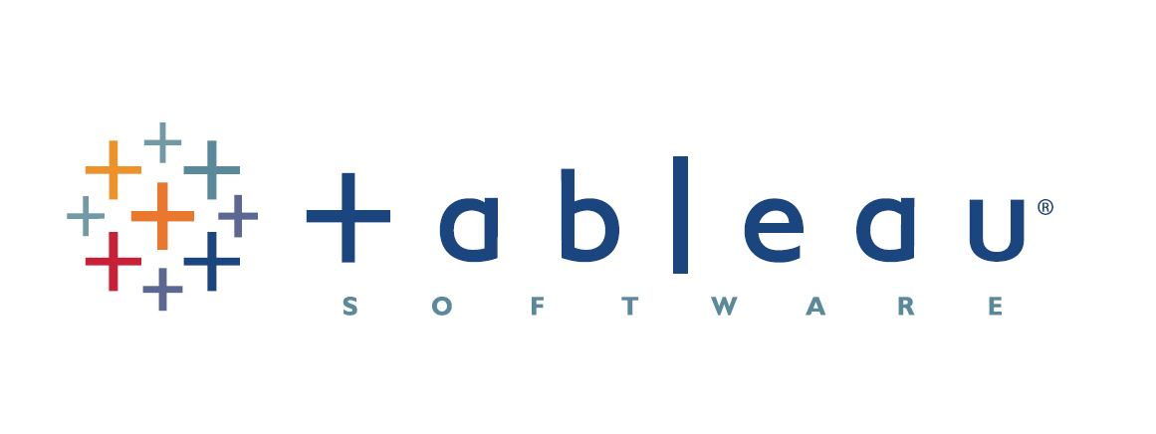

**Required Readings:**

Erl, T., Khattak, W. & Buhler, P. (2016). **Big Data Fundamentals**: Concepts, Drivers & Techniques, Prentice Hall

**AWS Data Analytics Fundamentals** (DAF), <https://www.aws.training/Details/eLearning?id=35364>